**FOP LAB MANUAL 6**

**HOME TASKS**

**MECHANICAL ENGINEERING BATCH 15**

**SECTION B**

**Name:**

MUHAMMAD SHAHZEB KHAN

**registration#**

479677

**submitted to**

LAB INSTRUCTOR SIR AFFAN

**Task 1:**

#include<iostream>

using namespace std;

int main() {

int sum = 0;

for (int i = 2; i <= 50; i++) {

bool isPrime = true; // Flag to identify prime numbers

for (int j = 2; j < i; j++) {

if (i % j == 0) {

isPrime = false;

break; // If a divisor is found, it's not prime; exit the loop

}

}

if (isPrime) {

sum =sum+ i; // Add the prime number to the sum

}

}

cout << sum;

return 0;

}

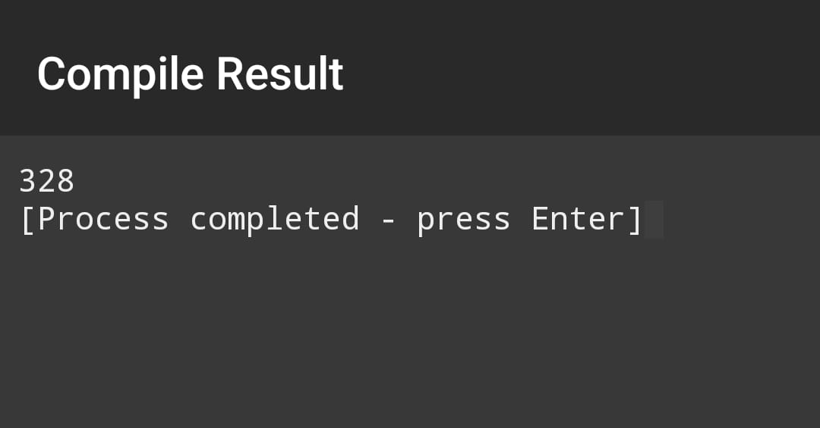

**Task 2:**

#include<iostream>

using namespace std;

int main ()

{

int i,j,rows;// declared variables

cout<<"enter number of required rows"<<endl;

cin>>rows;// demanding number of rows of required code

cout<<endl;

//applying for loop to print given number of rows

for(i=1;i<=rows;i++)

// applying another for loop to print numbers within the rows

{

for(j=1;j<=i;j++){

// printing out the numbers after each time loop runs

cout<<j<<'\t';

}

cout<<endl;

}

}

**Task 3:**

#include<iostream>

using namespace std;

int main ()

{

int i,j,rows; // declared variables

int num=1;

cout<<"enter number of required rows"<<endl;

cin>>rows;// demanding number of rows of required code

cout<<endl;

cout<<num<<endl;

num++;

//applying for loop to print given number of rows

for(i=2;i<=rows+2;i+=2)

// applying another for loop to print numbers within the rows

{

for(j=1;j<=i;j++){

// printing out the numbers after each time loop runs

cout<<num<<" ";

}

num=num+2;

cout<<endl;

}

}

